**Steps to Run Maven JAR**

**Prerequisites:**

- JDK 1.8 should be installed and JDK path should be set properly.

- Download Maven build tool and set 'MAVEN_HOME' path.

1. Download Latest jar ShopClues06.jar from Google Drive.
2. Create an Empty folder (Shpclues_06_Dec_Jar)
3. Create a folder inside this folder <ShopClues> & paste the JAR inside this folder (Executable.Jar)

E.g.: D:\Shpclues_06_Dec_Jar\ShopClues\shopclues06.jar

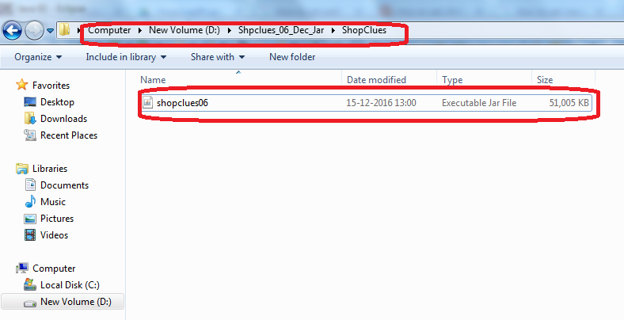

1. Open Command Prompt from current folder.
   1. Press ALT + SHIFT and Right Click on current jar folder

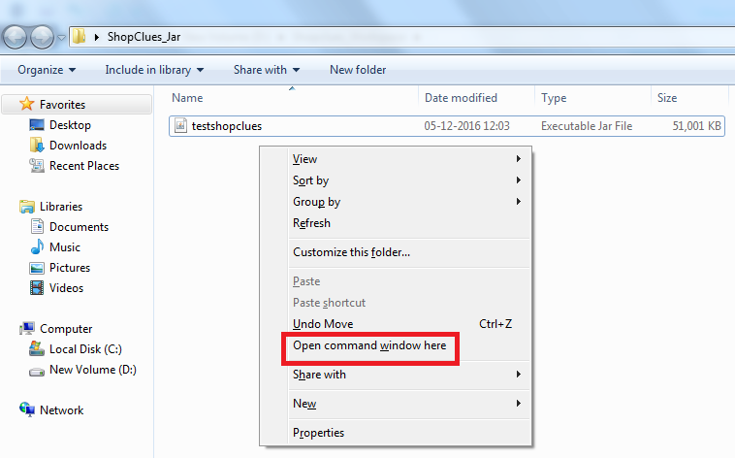

* 1. Click on Open command window here

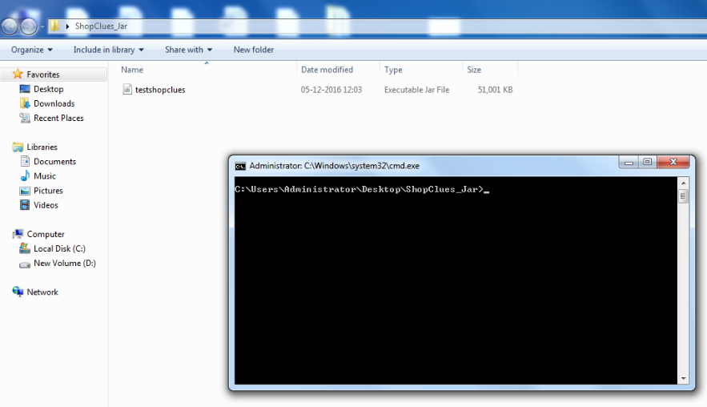

1. Type command **java –jar filename.jar** and press Enter.

E.g.: C:\Users\Administrator\Desktop\Shop>java -jar **shopclues06.jar**

(Do not specify the path of that file, only provide the filename as specified above.)

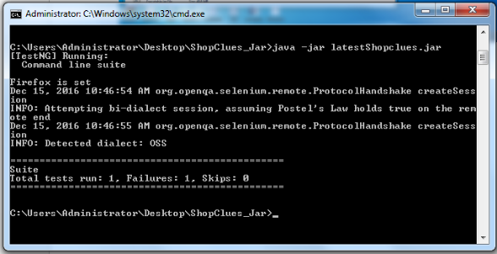

1. Properties file will be generated along with the Executable Jar file

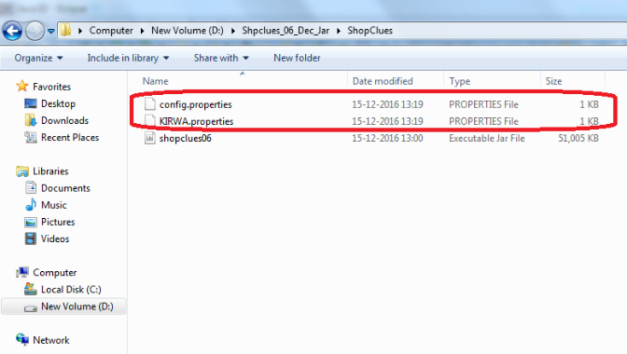

1. Reports folder will be created outside the current jar folder.

E.g.: D:\Shpclues_06_Dec_Jar\ShopClues

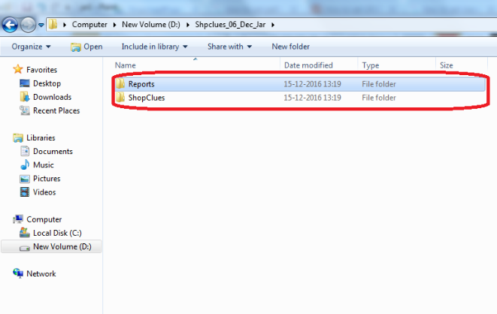

**- END -**